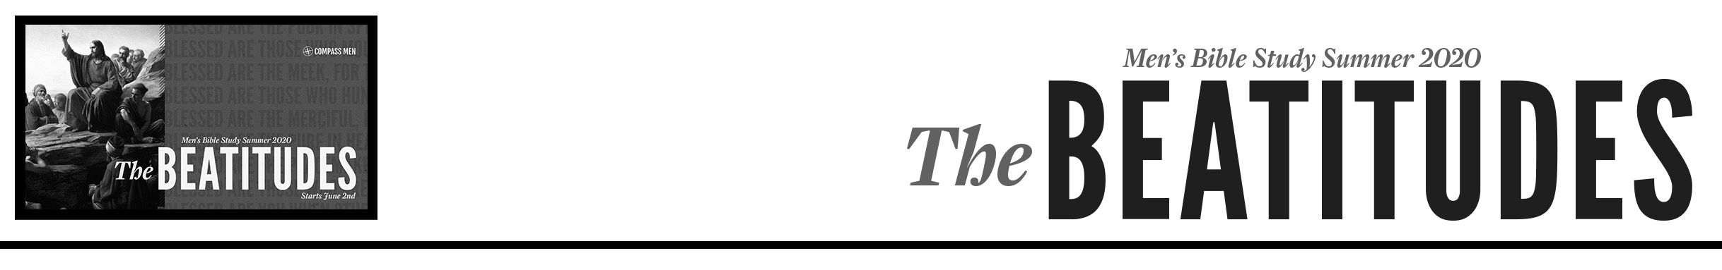
Pastor PJ Berner • Compass Bible Church • June 2nd & June 3rd, 2020 • The Point of the Sermon

- ______________________________________________________

- ______________________________________________________

- ______________________________________________________

- ______________________________________________________

Application Questions:
- Given the various approaches to the Sermon on the Mount discussed in the introduction to this message, which of these have you typically embraced in your reading of Matthew 5-7?
  - Super-law = meant to reinforce our incapability of keeping the law and our need for Jesus
  - Checklist of righteousness = prescriptions for how we should live as Christians in this world
  - Social reform = blueprints for creating a better world
  - Israel’s problem = commands given to the Jews but not necessarily for the church

- Of the four reasons why we should study the Sermon on the Mount given by James Boyce, which of them resonate(s) most with you and why?
  - Drives us to the gospel
  - Shows us more of Jesus
  - Provides a pathway to blessing
  - Reveals the roadmap to a life that is pleasing to God

- Describe the relationship between our pursuit of godliness and our pursuit of Jesus.

  - What are some ways that we can err in these pursuits one way or the other (godliness without Jesus and Jesus without godliness)?

  - What are some ways that we can practically increase our love of Jesus?

  - How should this increased love of Jesus promote in us a greater godliness?

- Read the following article from John Piper: https://www.desiringgod.org/interviews/the-key-to-our-victory-over-sin
  - How should we understand the balance of God’s enabling grace and our human responsibility in our pursuit of godliness?

- Read through the Beatitudes in Matthew 5:3-12.
  - If the Greek word translated “blessed” at the beginning of each of these means “happy” or “fortunate”, what do you notice from these verses about happiness in God’s economy as opposed to happiness in the world’s economy?

  - If the goal of the Beatitudes is to increase our love for Christ, what do the Beatitudes do to our understanding of happiness?

- What thoughts come to mind when you consider a “kingdom”?

  - How might these concepts relate to our identity as Christians?

  - Describe in your own words the concept of the kingdom of heaven as “already-but-not-yet”.

- What is one area of your life that this sermon where this sermon/passage has exposed a need for prayer, and how can we pray for you toward that end this week?

