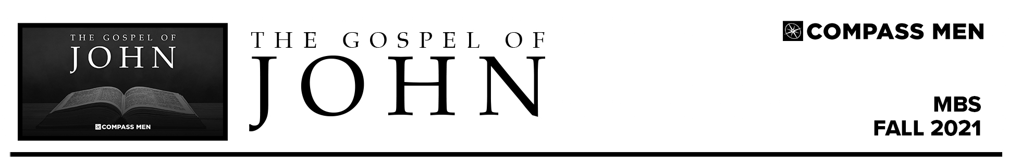

Pastor PJ Berner • Compass Bible Church • August 31 & September 3, 2021 • John 1:1-18
MEET JESUS

- __________________________________________________

- __________________________________________________

- __________________________________________________

DISCUSSION QUESTIONS

- Using a study bible or background commentary, list some of the key themes that we will encounter during our study of the book of John.

- Read John 20:30-31. According to these verses, what is the purpose for John’s writing this book? If John wrote this book for this purpose, what benefit might it have for those who are studying it as already saved?

- Read John 1:1. What three truths about the Word are affirmed in this opening verse?

- Who is the Word, and how do you know this from only reading John 1:1-18?

- Read John 1:1 and then read this article from Logos.com:
https://blog.logos.com/2-ways-jesus-is-the-word-of-god-revelation-and-logos/
  - How does Hebrews 1:1-3 help us understand what John meant by referring to Jesus as the Word?

  - What are some observations from this article that you were able to glean to help in your understanding of what it means that Jesus is the Word of God?

- John 1:1 poses major problems for cults like Mormonism, which ultimately led to Joseph Smith perverting the text in his “translation.” Read this article from CARM: https://carm.org/mormonism/the-joseph-smith-translation-and-john-11/. Then, make some observations regarding how you might defend the orthodox reading of this verse when a Mormon attempts to convince you that it is wrong.

- In John 1:1-5 what other evidence does John provide for the full deity of the Word?

- Read John 1:6-8. Which John is this? How do you know from the context? What was his job?

- Read John 1:9. The idea of Jesus as the “Light of the World” will be developed throughout John’s gospel. Upon your initial observations from this verse, what would you say it means that Jesus is the “true light, which gives light to everyone?”

- Read John 1:10-13. These verses are about Jesus’ role in making people children of God. In these verses list the actions of man versus the actions of Jesus. Comparing these two lists, who is responsible for our salvation?

- Read John 1:14. From this verse we get the concept of the “incarnation,” that is, that the Son of God took on flesh. Read Philippians 2:5-8. Though John describes it so poetically, describe what Jesus went through when “the Word became flesh and dwelt among us.” What did he experience for the first time?

- Read John 1:14 and 1:18. What was John saying about the relationship of Jesus and the Father? What does it mean that Jesus has “made [God] known?”

- As we begin this study of John, what do you hope to get out of your time? How are you expecting this book study to change your current relationship with God?

