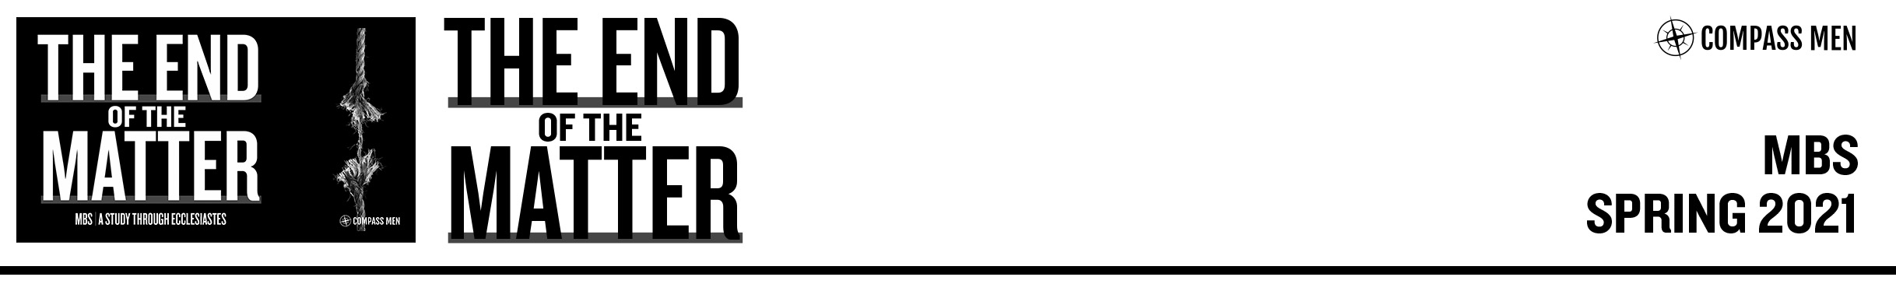

Pastor Rod Gomez • Compass Bible Church • April 27-28, 2021 • Eccl 9:13–10:20

**Wisdom Is Still Better**

1. **__________________________________________________**
2. **__________________________________________________**
3. **__________________________________________________**

**DISCUSSION QUESTIONS**

1. Read [Ecclesiastes 9:13-16](https://ref.ly/logosref/bible$2Besv.21.9.13-21.9.16). What is the moral of the story that Solomon tells in these verses? How have you observed this to be true in life?
2. Read [Ecclesiastes 9:17-18](https://ref.ly/logosref/bible$2Besv.21.9.17-21.9.18). Solomon clearly values wisdom but also recognizes its limitations. Explain in your own words how he makes this point in verses 17 and 18.
3. Read [Ecclesiastes 10:1](https://ref.ly/logosref/bible$2Besv.21.10.1). What does this verse have to say about integrity?
4. Read [Ecclesiastes 10:2-3](https://ref.ly/logosref/bible$2Besv.21.10.2-21.10.3). Folly is impossible to hide. How have you found this to be true in your life?

1. Read [Ecclesiastes 10:4-7](https://ref.ly/logosref/bible$2Besv.21.10.4-21.10.7). As Solomon reflects on the power structures of the world, what is his frustration in these verses?
2. Read [Ecclesiastes 10:8-10](https://ref.ly/logosref/bible$2Besv.21.10.8-21.10.10). What element of wise work is being discussed in these verses, particularly verse 10.

1. Read [Ecclesiastes 10:11](https://ref.ly/logosref/bible$2Besv.21.10.11). What principle of wisdom regarding how one approaches a task is Solomon stressing in this verse?

1. Read [Ecclesiastes 10:12-14](https://ref.ly/logosref/bible$2Besv.21.10.12-21.10.14); [Proverbs 15:2](https://ref.ly/logosref/bible$2Besv.20.15.2), [28](https://ref.ly/logosref/bible$2Besv.20.15.28); [18:7](https://ref.ly/logosref/bible$2Besv.20.18.7); [21:23](https://ref.ly/logosref/bible$2Besv.20.21.23). Contrast how the wise man uses his speech with how the fool runs his mouth from these texts.

1. Read [Ecclesiastes 10:15](https://ref.ly/logosref/bible$2Besv.21.10.15), [18](https://ref.ly/logosref/bible$2Besv.21.10.18) and [Proverbs 19:24](https://ref.ly/logosref/bible$2Besv.20.19.24). What element of folly is Solomon condemning in this verse?
2. Read [Ecclesiastes 10:16-17](https://ref.ly/logosref/bible$2Besv.21.10.16-21.10.17). According to these verses, what traits should we look for in our leaders? What traits should we avoid?
3. Read [Ecclesiastes 10:19](https://ref.ly/logosref/bible$2Besv.21.10.19). Solomon makes an observation about life in this world. Put this into your own words.
4. Read [Ecclesiastes 10:20](https://ref.ly/logosref/bible$2Besv.21.10.20). Solomon warns against rebelling against God’s anointed even in our thought-life or in the privacy of our own rooms. Connect this concept back to [Ecclesiastes 10:1](https://ref.ly/logosref/bible$2Besv.21.10.1).
5. In this chapter we find a compendium of proverbial statements. Which of these are the most impactful to you and why?